**CHAPTER 1**

**INTRODUCTION**

In recent years, with the increasing use of mobile devices, there is a growing trend to move almost all real-world operations to the cyberworld. Although this makes easy our daily lives, it also brings many security breaches due to the anonymous structure of the Internet. Used antivirus programs and firewall systems can prevent most of the attacks. However, experienced attackers target on the weakness of the computer users by trying to phish them with bogus webpages. These pages imitate some popular banking, social media, e-commerce, etc. sites to steal some sensitive information such as, user-ids, passwords, bank account, credit card numbers, etc. Phishing detection is a challenging problem, and many different solutions are proposed in the market as a blacklist, rule-based detection, anomaly-based detection, etc. In the literature, it is seen that current works tend on the use of machine learning-based anomaly detection due to its dynamic structure, especially for catching the “zero-day” attacks. In this project, the proposed a machine learning-based phishing detection system by using eight different algorithms to analyze the URLs, and three different datasets to compare the results with other works. The experimental results depict that the proposed models have an outstanding performance with a success rate

**CHAPTER 2**

**SYSTEM ANALYSIS**

* 1. **EXISTING SYSTEM**

Phishing is the most commonly used social engineering and cyber attack. Through such attacks, the phisher targets naïve online users by tricking them into revealing confidential information, with the purpose of using it fraudulently. In order to avoid getting phished, users should have awareness of phishing websites. Have a blacklist of phishing websites which requires the knowledge of website being detected as phishing. Detect them in their early appearance, using machine learning and deep neural network algorithms of the above three, the machine learning based method is proven to be most effective than the other methods. Even then, online users are still being trapped into revealing sensitive information in phishing websites. A phishing website is a common social engineering method that mimics trustful uniform resource locators (URLs) and webpages.

**DISADVANTAGES**

* In the phishing website analysis the concern details will be kept unknown
* The concern details will be used by the developed hacker/ attacker
  1. **PROPOSED SYSTEM**

Therefore in the proposed system, different decision support or detection systems have been developed to protect the end user against phishing attacks. Different approaches are used in these systems, such as Blacklists, Rule-based systems, Similarity-based systems, and Machine Learning based systems, etc. The literature was reviewed in detail, and the studies in this context were examined carefully. Currently, machine learning-based systems are especially preferred for its protection mechanism to the zero-day attacks. Therefore, in this paper, it is aimed to implement a phishing detection system based on a machine learning algorithm for investigating the URL address of the target web page. With the idea of existing improvable ways of the designed system, it is aimed at the detection of phishing attacks in a short time, without the need for third-party services, and also without waiting for the blacklists to be updated. The project is organized as follows: in the next section, the literature review is included. In the third section, the details of the designed system are explained. In the fourth section and fifth section, the results obtained in the experiments are shared, and conclusion and future studies are drawn, respectively.

**ADVANTAGES**

* The proposed system makes a advantage of the created system
* The user will be free from the phishing website
  1. **FEASIBILITY STUDY**

There are number of users who purchase products online and make payment through various websites. There are multiple websites who ask user to provide sensitive data such as username, password or credit card details etc. often for malicious reasons. This type of websites is known as phishing website. In order to detect and predict phishing website, we proposed an intelligent, flexible and effective system that is based on using classification Data mining algorithm. We implemented classification algorithm and techniques to extract the phishing data sets criteria to classify their legitimacy. The phishing website can be detected based on some important characteristics like URL and Domain Identity, and security and encryption criteria in the final phishing detection rate. Once user makes transaction through online when he makes payment through the website our system will use data mining algorithm to detect whether the website is phishing website or not. This application can be used by many E-commerce enterprises in order to make the whole transaction process secure. Data mining algorithm used in this system provides better performance as compared to other traditional classifications algorithms. With the help of this system user can also purchase products online without any hesitation. Admin can add phishing website url or fake website url into system where system could access and scan the phishing website and by using algorithm, it will add new suspicious keywords to database. System uses machine learning technique to add new keywords into database.

**CHAPTER 3**

**REQUIREMENT ANALYSIS**

**3.1 HARDWARE REQUIREMENTS**

* Processor : Dual core processor 2.6.0 GHZ
* RAM : 4GB
* Hard disk : 160 GB
* Compact Disk : 650 Mb
* Keyboard : Standard keyboard
* Monitor : 15 inch color monitor

**3.2 SOFTWARE REQUIREMENTS**

* Operating System :  Windows 10 Pro
* Language           :  PYTHON
* IDE : Dreamweaver
* Back End : MySQL Server

**CHAPTER 4**

**SYSTEM DESIGN**

**4.1 ARCHITECTURE DIAGRAM**

A system architecture or systems architecture is the conceptual model that defines the structure, behavior, and more views of a system. An architecture description is a formal description and representation of a system, organized in a way that supports reasoning about the structures and behaviors of the system. System architecture can comprise system components, the externally visible properties of those components, the relationships (e.g. the behavior) between them. It can provide a plan from which products can be procured, and systems developed, that will work together to implement the overall system. There have been efforts to formalize languages to describe system architecture; collectively these are called architecture description languages (ADLs).

**Various organizations define systems architecture in different ways, including:**

* An allocated arrangement of physical elements which provides the design solution for a consumer product or life-cycle process intended to satisfy the requirements of the functional architecture and the requirements baseline.
* Architecture comprises the most important, pervasive, top-level, strategic inventions, decisions, and their associated rationales about the overall structure (i.e., essential elements and their relationships) and associated characteristics and behavior.
* If documented, it may include information such as a detailed inventory of current hardware, software and networking capabilities; a description of long-range plans and priorities for future purchases, and a plan for upgrading and/or replacing dated equipment and software
* The composite of the design architectures for products and their life-cycle processes.

**PHISHING WEBSITE DETECTION**

Admin

Block website

View Website

Database

Website Holder

Register

Access data

Login

Login

View Website Holder

Add website

Website Holder

Register

Login

data Access

**Fig 4.1 System architecture of the proposed system**

**4.2 CONTEXT DIAGRAM**

Context diagrams show the interactions between a system and other actors (external factors) with which the system is designed to interface. System context diagrams can be helpful in understanding the context which the system will be part of.

Phishing website detection

Website Holder

Admin

Database

**Fig 4.2 Context Diagram**

**4.3 USE CASE DIAGRAM**

A use case diagram at its simplest is a representation of a user's interaction with the system that shows the relationship between the user and the different use cases in which the user is involved. In this context, a "system" is something being developed or operated, such as a web site. The "actors" are people or entities operating under defined roles within the system.

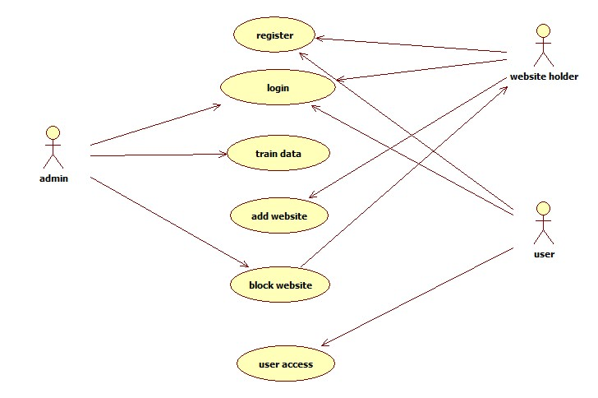

**Fig 4.3 Use case Diagram**

**4.4 CLASS DIAGRAM**

A class diagram in the Unified Modeling Language (UML) is a type of static structure diagram that describes the structure of a system by showing the system's classes, their attributes, operations and the relationships among objects. The class diagram is the main building block of object-oriented modeling. It is used for general conceptual modeling of the systematic of the application, and for detailed modeling translating the models into programming code

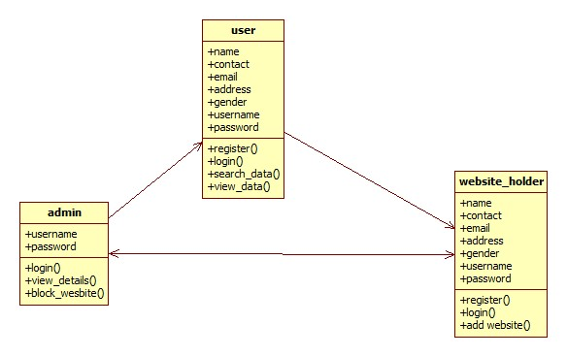

**Fig 4.4 Class Diagrams**

**4.5 SEQUENCE DIAGRAM**

A sequence diagram shows object interactions arranged in time sequence. It depicts the objects and classes involved in the scenario and the sequence of messages exchanged between the objects needed to carry out the functionality of the scenario. Sequence diagrams are typically associated with use case realizations in the Logical View of the system under development. Sequence diagrams are sometimes called event diagrams or event scenarios.

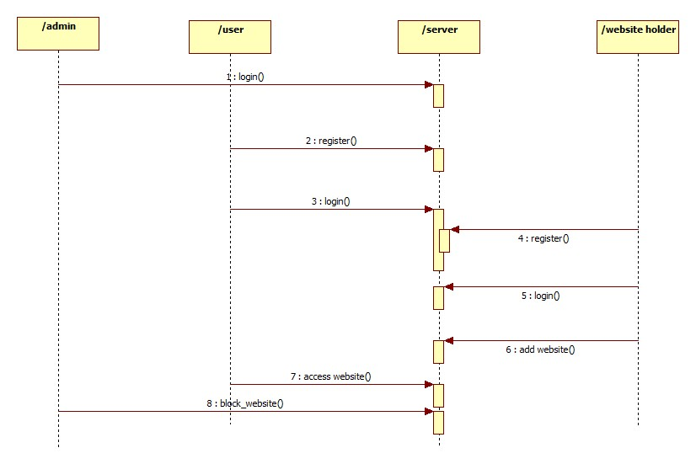

**Fig 4.5 Sequence Diagram**

**CHAPTER 4**

**SOFTWARE DESIGN**

**4.1 SOFTWARE INTERFACE DESIGN**

**PYTHON**

Python is an interpreted, object-oriented, high-level programming language with dynamic semantics. Its high-level built in data structures, combined with dynamic typing and dynamic binding, make it very attractive for Rapid Application Development, as well as for use as a scripting or glue language to connect existing components together. Python's simple, easy to learn syntax emphasizes readability and therefore reduces the cost of program maintenance. Python supports modules and packages, which encourages program modularity and code reuse. The Python interpreter and the extensive standard library are available in source or binary form without charge for all major platforms, and can be freely distributed.

Often, programmers fall in love with Python because of the increased productivity it provides. Since there is no compilation step, the edit-test-debug cycle is incredibly fast. Debugging Python programs is easy: a bug or bad input will never cause a segmentation fault. Instead, when the interpreter discovers an error, it raises an exception. When the program doesn't catch the exception, the interpreter prints a stack trace. A source level debugger allows inspection of local and global variables, evaluation of arbitrary expressions, setting breakpoints, stepping through the code a line at a time, and so on. The debugger is written in Python itself, testifying to Python's introspective power. On the other hand, often the quickest way to debug a program is to add a few print statements to the source: the fast edit-test-debug cycle makes this simple approach very effective.

**5.2 FEATURES IN PYTHON**

There are many features in Python, some of which are discussed below –

**1.Easy to code:**

Python is high level programming language. Python is very easy to learn language as compared to other language like c, c#, java script, javaetc.It is very easy to code in python language and anybody can learn python basic in few hours or days.It is also developer-friendly language.

**2. Free and Open Source:**

Python language is freely available at official website and you can download it from the given download link below click on the Download Python keyword.

**Download Python**

Since, it is open-source; this means that source code is also available to the public. So you can download it as, use it as well as share it.

**3.Object-Oriented Language:**

One of the key features of python is Object-Oriented programming. Python supports object oriented language and concepts of classes, objects encapsulation etc.

**4. GUI Programming Support:**

Graphical Users interfaces can be made using a module such as PyQt5, PyQt4, wxPython or Tk in python.

PyQt5 is the most popular option for creating graphical apps with Python.

**5. High-Level Language:**

Python is a high-level language. When we write programs in python, we do not need to remember the system architecture, nor do we need to manage the memory.

**6.Extensible feature:**

Python is a Extensible language. we can write our some python code into c or c++ language and also we can compile that code in c/c++ language.

**7. Python is Portable language:**

Python language is also a portable language. for example, if we have python code for windows and if we want to run this code on other platform such as Linux, Unix and Mac then we do not need to change it, we can run this code on any platform.

**8. Python is integrated language:**

Python is also an integrated language because we can easily integrated python with other language like c, c++ etc.

**9. Interpreted Language:**

Python is an Interpreted Language. because python code is executed line by line at a time. like other language c, c++, java etc there is no need to compile python code this makes it easier to debug our code.The source code of python is converted into an immediate form called bytecode.

**10. Large Standard Library**

Python has a large standard library which provides rich set of module and functions so you do not have to write your own code for every single thing.There are many libraries present in python for such as regular expressions, unit-testing, web browsers etc.

**11. Dynamically Typed Language:**

Python is dynamically-typed language. That means the type (for example- int, double, long etc) for a variable is decided at run time not in advance.because of this feature we don’t need to specify the type of variable.

Machine Learning is the hottest trend in modern times. According to Forbes, Machine learning patents grew at a 34% rate between 2013 and 2017 and this is only set to increase in the future. And Python is the primary programming language used for much of the research and development in Machine Learning. Python is currently the most popular programming language for research and development in Machine Learning. But you don’t need to take my word for it! According to GoogleTrends, the interest in Python for Machine Learning has spiked to an all-new high with other ML languages such as R, Java, Scala, Julia, etc. lagging far behind.

**MYSQL (Back end)**

**Introduction**

MySQL is the world's most used open source relational database management system (RDBMS) as of 2008 that run as a server providing multi-user access to a number of databases. The MySQL development project has made its source code available under the terms of the GNU General Public License, as well as under a variety of proprietary agreements. MySQL was owned and sponsored by a single for-profit firm, the Swedish company MySQL AB, now owned by Oracle Corporation.

MySQL is a popular choice of database for use in web applications, and is a central component of the widely used LAMP open source web application software stack—LAMP is an acronym for "Linux, Apache, MySQL, Perl/PHP/Python." Free-software-open source projects that require a full-featured database management system often use MySQL.

For commercial use, several paid editions are available, and offer additional functionality. Applications which use MySQL databases include: TYPO3, Joomla, Word Press, phpBB, MyBB, Drupal and other software built on the LAMP software stack. MySQL is also used in many high-profile, large-scale World Wide Web products, including Wikipedia, Google (though not for searches), ImagebookTwitter, Flickr, Nokia.com, and YouTube.

**Inter Images**

MySQL is primarily an RDBMS and ships with no GUI tools to administer MySQL databases or manage data contained within the databases. Users may use the included command line tools, or use MySQL "front-ends", desktop software and web applications that create and manage MySQL databases, build database structures, back up data, inspect status, and work with data records. The official set of MySQL front-end tools, MySQL Workbench is actively developed by Oracle, and is freely available for use.

**Graphical**

The official MySQL Workbench is a free integrated environment developed by MySQL AB, which enables users to graphically administer MySQL databases and visually design database structures. MySQL Workbench replaces the previous package of software, MySQL GUI Tools. Similar to other third-party packages, but still considered the authoritative MySQL frontend, MySQL Workbench lets users manage database design & modeling, SQL development (replacing MySQL Query Browser) and Database administration (replacing MySQL Administrator).MySQL Workbench is available in two editions, the regular free and open source Community Edition which may be downloaded from the MySQL website, and the proprietary Standard Edition which extends and improves the feature set of the Community Edition.

**Command Line**

MySQL ships with some command line tools. Third-parties have also developed tools to manage a MySQL server, some listed below. Maatkit - a cross-platform toolkit for MySQL, PostgreSQL and Memcached, developed in Perl Maatkit can be used to prove replication is working correctly, fix corrupted data, automate repetitive tasks, and speed up servers. Maatkit is included with several GNU/Linux distributions such as CentOS and Debian and packages are available for Programming. MySQL works on many different system platforms, including AIX, BSDi, FreeBSD, HP-UX, eComStation, i5/OS, IRIX, Linux, Mac OS X, Microsoft Windows, NetBSD, Novell NetWare, OpenBSD, OpenSolaris, OS/2 Warp, QNX, Solaris, Symbian, SunOS, SCO Open Server, SCO UnixWare, Sanos and Tru64. A port of MySQL to OpenVMS also exists.

MySQL is written in C and C++. Its SQL parser is written in yacc, and a home-brewed lexical analyzer. Many programming languages with language-specific APIs include libraries for accessing MySQL databases. These include MySQL Connector/Net for integration with Microsoft's Visual Studio (languages such as C# and VB are most commonly used) and the JDBC driver for Java. In addition, an ODBC inter image called MyODBC allows additional programming languages that support the ODBC inter image to communicate with a MySQL database, such as ASP or ColdFusion. The HTSQL - URL-based query method also ships with a MySQL adapter, allowing direct interaction between a MySQL database and any web client via structured URLs.

**Features**

As of April 2009, MySQL offered MySQL 5.1 in two different variants: the open source MySQL Community Server and the commercial Enterprise Server. MySQL 5.5 is offered under the same licenses. They have a common code base and include the following features:

* A broad subset of ANSI SQL 99, as well as extensions
* Cross-platform support
* Stored procedures
* Triggers
* Cursors
* Updatable Views
* Information schema

**4.2 USER INTERFACE DESIGN**

# 

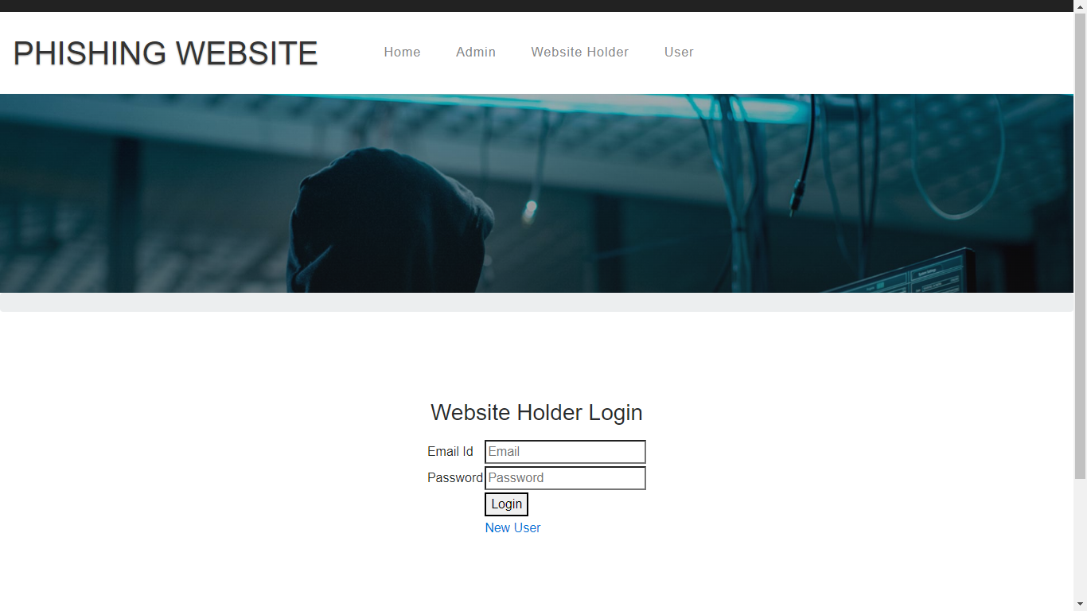

**4.3 DATABASE DESIGN**

**Access Details**

|  |  |  |  |
| --- | --- | --- | --- |
| **Field** | **Type** | **Null** | **Default** |
| id | int(100) | Yes | NULL |
| user_name | varchar(100) | Yes | NULL |
| file_id | varchar(100) | Yes | NULL |
| data_owner | varchar(100) | Yes | NULL |
| keyword | varchar(100) | Yes | NULL |
| description | varchar(100) | Yes | NULL |
| filename | varchar(100) | Yes | NULL |
| cdate | varchar(100) | Yes | NULL |

**Data Owner details**

|  |  |  |  |
| --- | --- | --- | --- |
| **Field** | **Type** | **Null** | **Default** |
| id | int(100) | Yes | NULL |
| name | varchar(100) | Yes | NULL |
| contact | varchar(100) | Yes | NULL |
| address | varchar(100) | Yes | NULL |
| city | varchar(100) | Yes | NULL |
| area | varchar(100) | Yes | NULL |
| gender | varchar(100) | Yes | NULL |
| email | varchar(100) | Yes | NULL |
| username | varchar(100) | Yes | NULL |
| password | varchar(100) | Yes | NULL |

**Upload Details**

|  |  |  |  |
| --- | --- | --- | --- |
| **Field** | **Type** | **Null** | **Default** |
| id | int(100) | Yes | NULL |
| data_owner | varchar(100) | Yes | NULL |
| keyword | varchar(100) | Yes | NULL |
| description | varchar(100) | Yes | NULL |
| filename | varchar(100) | Yes | NULL |

**User Details**

|  |  |  |  |
| --- | --- | --- | --- |
| **Field** | **Type** | **Null** | **Default** |
| id | int(100) | Yes | NULL |
| name | varchar(100) | Yes | NULL |
| contact | varchar(100) | Yes | NULL |
| email | varchar(100) | Yes | NULL |
| address | varchar(100) | Yes | NULL |
| username | varchar(100) | Yes | NULL |
| password | varchar(100) | Yes | NULL |

**CHAPTER 5**

**SYSTEM IMPLEMENTATION**

**5.1 MODULE DESCRIPTION**

**Admin**

* **Login** – admin will make a login with the default username and password session
* **View holder** – the admin will view the details of the website holder who all registered with the system
* **View websites** – the admin will view the details of the website links which has been added by the website holder
* **Block Websites** – The admin will block the unwanted websites from the concern website owner

**Website Holder**

* + **Register** – The website holder will make a registration with the personnel information
  + **Login** – The created account will be done with the username and password
  + **Add website** – The website holder will add the details of the websites with link for the load
  + **Website details** – The website owner will view the websites which are added

**User**

* **User Register –** The user will make a registration with their personnel details in the system
* **User Login –** The user login will be done with the extraction of the data which are shown where the login will be accessed
* **User Search –** the user may search the keyword based extraction where the best keyword search scheme development and the retrieval of data will be done using the binary search tree
* **Data usage –** the data usage will be done with the extraction of the usage verification system

**5.2 IMPLEMENTATION DETAILS**

**5.2.1 INSTALLATION PROCEDURE**

**Introduction**

Python is a widely used high-level programming language first launched in 1991. Since then, Python has been gaining popularity and is considered as one of the most popular and flexible server-side programming languages.

Unlike most Linux distributions, Windows does not come with the Python programming language by default. However, you can install Python on your Windows server or local machine in just a few easy steps.

**PREREQUISITES**

* A system running Windows 10 with admin privileges
* Command Prompt (comes with Windows by default)
* A Remote Desktop Connection app (use if you are installing Python on a remote Windows server)

**PYTHON INSTALLATION ON WINDOWS**

### Step 1: Select Version of Python to Install

The installation procedure involves downloading the official Python .exe installer and running it on your system.

The version you need depends on what you want to do in Python. For example, if you are working on a project coded in Python version 2.6, you probably need that version. If you are starting a project from scratch, you have the freedom to choose.

If you are learning to code in Python, we recommend you **download both the latest version of Python 2 and 3**. Working with Python 2 enables you to work on older projects or test new projects for backward compatibility.

**Step 2: Download Python Executable Installer**

1. Open your web browser and navigate to the [Downloads for Windows section](https://www.python.org/downloads/windows/) of the [official Python website](https://www.python.org/).
2. Search for your desired version of Python. At the time of publishing this article, the latest Python 3 release is version 3.7.3, while the latest Python 2 release is version 2.7.16.
3. Select a link to download either the **Windows x86-64 executable installer** or **Windows x86 executable installer**. The download is approximately 25MB.

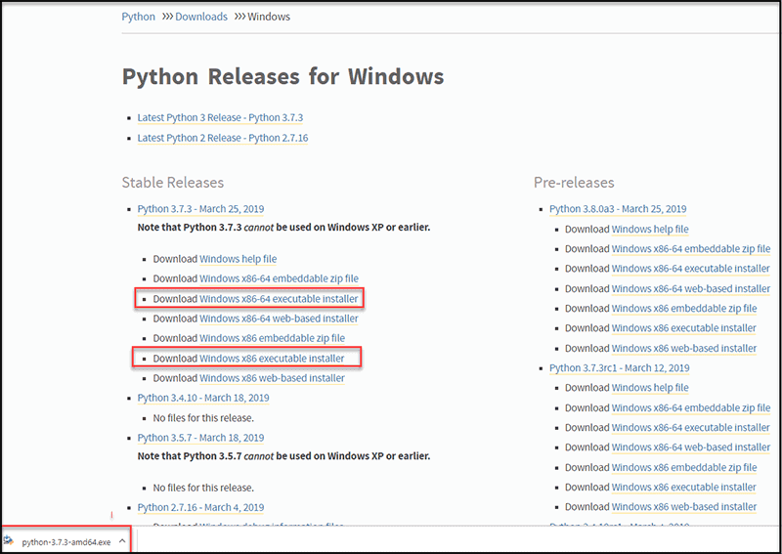

**Step 3: Run Executable Installer**

1. Run the **Python Installer** once downloaded. (In this example, we have downloaded Python 3.7.3.)

2. Make sure you select the **Install launcher for all users** and **Add Python 3.7 to PATH** checkboxes. The latter places the interpreter in the execution path. For older versions of Python that do not support the **Add Python to Path** checkbox, see [Step 6](https://phoenixnap.com/kb/how-to-install-python-3-windows#htoc-step-5-add-python-path-to-environment-variables-optional).

3. Select **Install Now** – the recommended installation options.

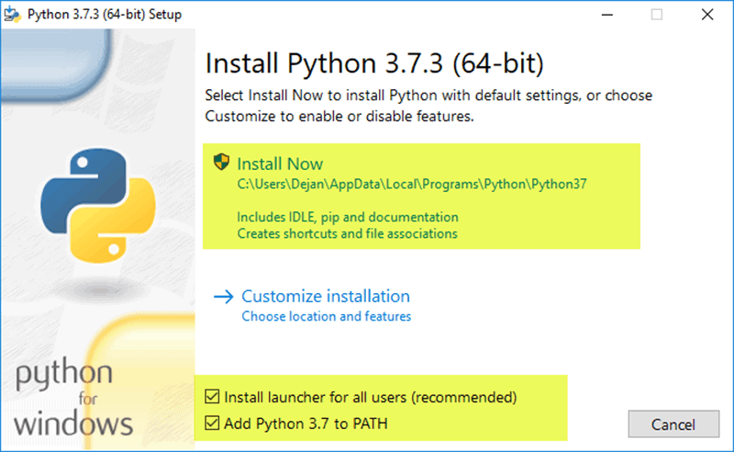

For all recent versions of Python, the recommended installation options include **Pip** and **IDLE**. Older versions might not include such additional features.

4. The next dialog will prompt you to select whether to **Disable path length limit**. Choosing this option will allow Python to bypass the 260-character MAX_PATH limit. Effectively, it will enable Python to use long path names

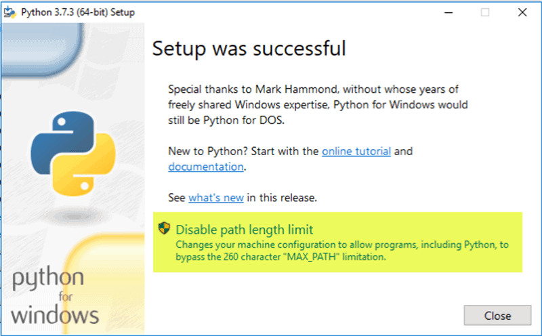

The Disable path length limit option will not affect any other system settings. Turning it on will resolve potential name length issues that may arise with Python projects developed in Linux.

### Step 4: Verify Python Was Installed On Windows

1. Navigate to the directory in which Python was installed on the system. In our case, it is **C:\Users\**Username**\AppData\Local\Programs\Python\Python37**since we have installed the latest version.
2. Double-click **python.exe**.
3. The output should be similar to what you can see below:

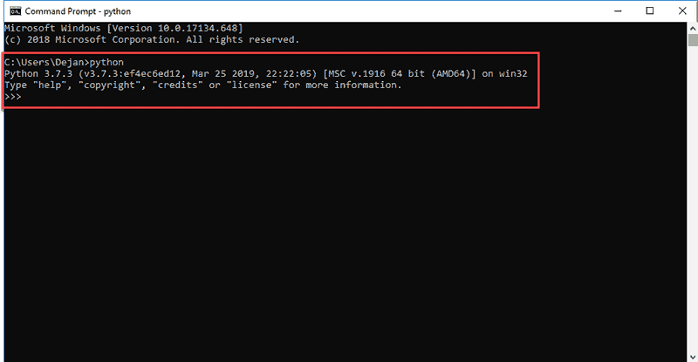

Step 5: Verify Pip Was Installed

If you opted to install an older version of Python, it is possible that it did not come with Pip preinstalled. Pip is a powerful package management system for Python software packages. Thus, make sure that you have it installed.

We recommend using Pip for most Python packages, especially when working in virtual environments.

To verify whether Pip was installed:

1. Open the Start menu and type “cmd.”
2. Select the Command Prompt application.
3. Enter pip -V in the console. If Pip was installed successfully, you should see the following output:

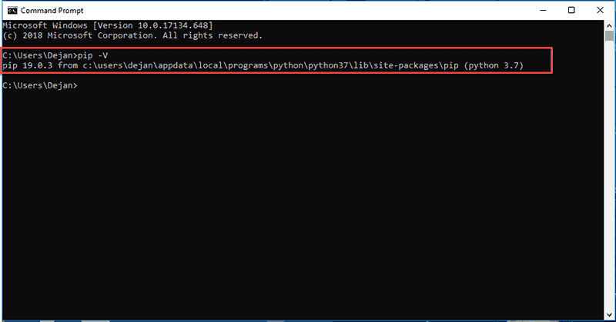

Step 6: Add Python Path to Environment Variables (Optional)

We recommend you go through this step if your version of the Python installer does not include the Add Python to PATH checkbox or if you have not selected that option.

Setting up the Python path to system variables alleviates the need for using full paths. It instructs Windows to look through all the PATH folders for “python” and find the install folder that contains the python.exe file.

1. Open the Start menu and start the Run app.

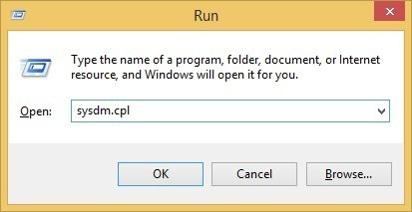

2. Type **sysdm.cpl**and click **OK**. This opens the **System Properties** window.

3. Navigate to the **Advanced** tab and select **Environment Variables**.

4. Under **System Variables**, find and select the **Path** variable.

5. Click **Edit**.

6. Select the **Variable value** field. Add the path to the **python.exe** file preceded with a **semicolon** **(;)**. For example, in the image below, we have added “**;C:\Python34.**”

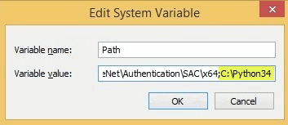

7. Click **OK** and close all windows.

By setting this up, you can execute Python scripts like this: **Python script.py**

Instead of this: **C:/Python34/Python script.py**

As you can see, it is cleaner and more manageable.

**CHAPTER 6**

**SYSTEM TESTING**

Testing is a set activity that can be planned and conducted systematically. Testing begins at the module level and work towards the integration of entire computers based system. Nothing is complete without testing, as it is vital success of the system.

Testing Objectives:

There are several rules that can serve as testing objectives, they are

1. Testing is a process of executing a program with the intent of finding an error
2. A good test case is one that has high probability of finding an undiscovered error.
3. A successful test is one that uncovers an undiscovered error.

If testing is conducted successfully according to the objectives as stated above, it would uncover errors in the software. Also testing demonstrates that software functions appear to the working according to the specification, that performance requirements appear to have been met.

There are three ways to test a program

1. For Correctness
2. For Implementation efficiency
3. For Computational Complexity.

Tests used for implementation efficiency attempt to find ways to make a correct program faster or use less storage. It is a code-refining process, which reexamines the implementation phase of algorithm development. Tests for computational complexity amount to an experimental analysis of the complexity of an algorithm or an experimental comparison of two or more algorithms, which solve the same problem.

The data is entered in all forms separately and whenever an error occurred, it is corrected immediately. A quality team deputed by the management verified all the necessary documents and tested the Software while entering the data at all levels.

**6.1 TYPES OF TESTING**

The development process involves various types of testing. Each test type addresses a specific testing requirement. The most common types of testing involved in the development process are:

* Unit Test
* Integration Test
* System Test
* Validation Test

**6.1.1 Unit Testing:**

The first test in the development process is the unit test. The source code is normally divided into modules, which in turn are divided into smaller units called units. These units have specific behavior. The test done on these units of code is called unit test. Unit test depends upon the language on which the project is developed. Unit tests ensure that each unique path of the project performs accurately to the documented specifications and contains clearly defined inputs and expected results.

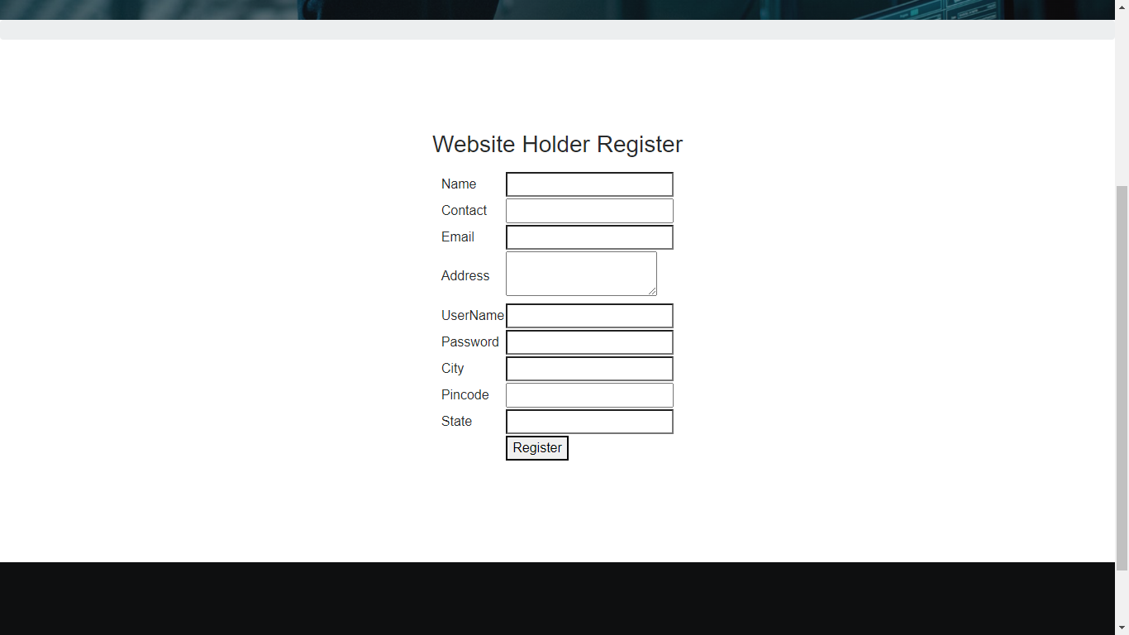

**Fig 6.1 Unit testing**

**6.1.2 Integration Testing:**

In integration testing modules are combined and tested as a group. Modules are typically code modules, individual applications, source and destination applications on a network, etc. Integration Testing follows unit testing and precedes system testing. Testing after the product is code complete. Betas are often widely distributed or even distributed to the public at large in hopes that they will buy the final product when it is released.



**Fig 6.2 Integration testing**

**6.1.3 System Testing**

System testing is defined as testing of a complete and fully integrated software product. This testing falls in black-box testing wherein knowledge of the inner design of the code is not a pre-requisite and is done by the testing team. It is the final test to verify that the product to be delivered meets the specifications mentioned in the requirement document. It should investigate both functional and non-functional requirements.

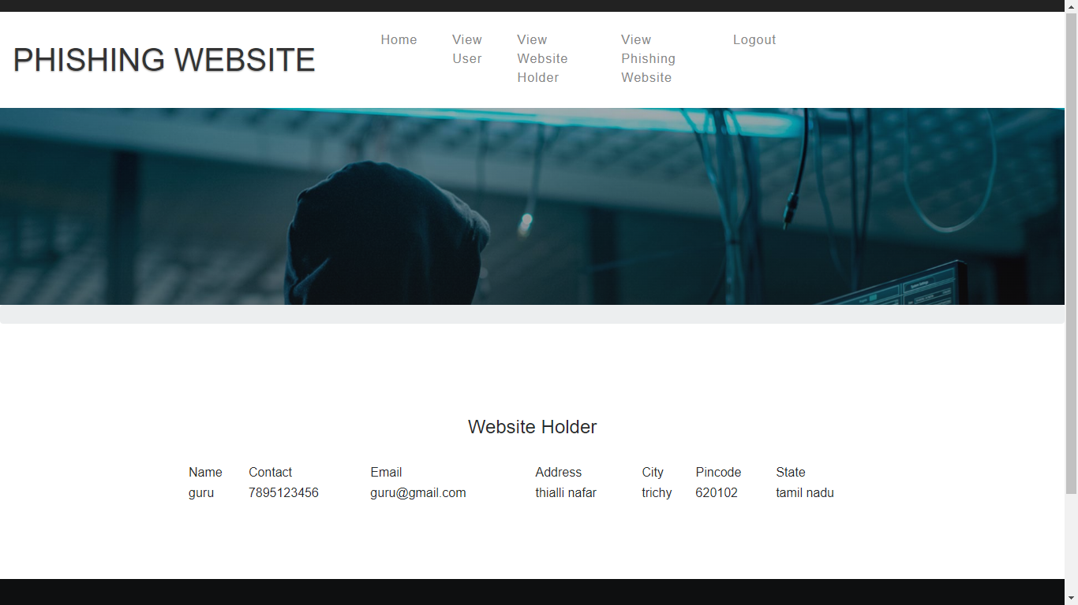

**Fig 6.3 System Testing**

**6.1.4 Validation Testing**

The process of evaluating software during the development process or at the end of the development process to determine whether it satisfies specified business requirements. Validation Testing ensures that the product actually meets the client's needs. It can also be defined as to demonstrate that the product fulfills its intended use when deployed on appropriate environment

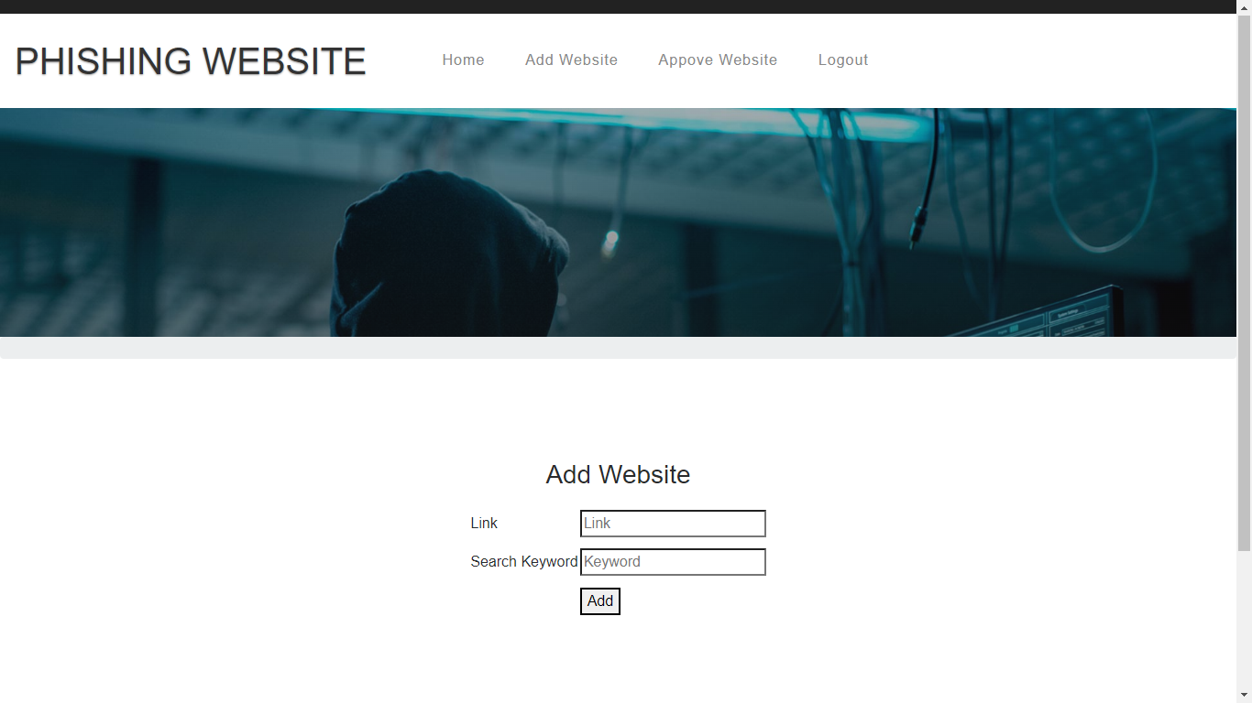

**Fig 6.4 Validation verification**

**CHAPTER 7**

**CONCLUSION AND FUTURE ENHANCEMENT**

**7.1 CONCLUSION**

In this project, explored how well to classify phishing URLs from the given set of URLs containing benign and phishing URLs. We have also discussed the randomization of the dataset, feature engineering, feature extraction using lexical analysis host-based features and statistical analysis. We have also used different classifiers for the comparative study and found that the findings are almost consistent across the different classifiers. We also observed dataset randomization yielded a great optimization and the accuracy of the classifier improved significantly. We have adopted a simple approach to extract the features from the URLs using simple regular expressions. There could be more features that can be experimented and that might lead to improving further the accuracy of the system.

**7.2 FUTURE ENHANCEMENT**

# In the future enhancements, the multiple prediction of the maintenance approach over the detection of the algorithm variants and its accuracy

**CHAPTER 8**

**BIBLIOGRAPHY**

**BOOK REFERENCES**

# [1] Eric Matthes,” [Python Crash Course](https://geni.us/940d)”, 2nd edition 2020 – ISBN: 1393986870

[2] Mark Lutz “[Python Pocket Reference: Python in Your Pocket](http://geni.us/vb1l1)”, 5th edition  2023- ISBN:  9789351106302

# [3] [R. Nageswara Rao](https://www.amazon.in/s/ref=dp_byline_sr_book_1?ie=UTF8&field-author=R.+Nageswara+Rao&search-alias=stripbooks), “Core Python Programming, 3ed”, Dreamtech Press (1 September 2021); Wiley India Pvt Ltd. 1402, 14th Floor, World Trade Tower Plot No. C - 1, Sector – 16, Noida – 201301 – ISBN: 9390457157

**WEB REFERENCES**

1. <https://www.researchgate.net/publication/325028205_A_TwoStep_Resume_Information_Extraction_Algorithm>
2. <https://www.google.com/search?q=resume+scrapping+pdf&rlz=1C1JJTC_enIN1008IN1009&oq=resume+scrapping+pdf+&aqs=chrome..69i57j33i10i160l3.17936j0j15&sourceid=chro>

# CHAPTER 9

**ANNEXURES**

**9.1 SOURCE CODE**

**Home py**

import os

import random

from datetime import date

import re

from urllib import request

import smtplib, ssl

from flask import Flask, render_template, flash, request, session, current_app, send_from_directory

from werkzeug.utils import redirect, secure_filename

import ar_master

# ps = PorterStemmer()

app = Flask(__name__, static_folder="static")

app.config.from_object(__name__)

app.config['SECRET_KEY'] = '7d441f27d441f27567d441f2b6176a'

user='root'

password=''

host='localhost'

mm = ar_master.master_flask_code()

################################################################### HOME

@app.route("/")

def homepage():

return render_template('index.html')

@app.route("/admin")

def admin():

return render_template('admin.html')

@app.route("/admin_login", methods = ['GET', 'POST'])

def admin_login():

if request.method == 'POST':

if request.form['uname'] == 'admin' and request.form['pass'] == 'admin':

return render_template('admin_home.html', flash_message = True, data = "Success")

else:

print("else")

return render_template('admin.html', flash_message = True, error='Incorrect Username or Password',data = "Failed")

@app.route("/admin_home")

def admin_home():

return render_template('admin_home.html')

@app.route("/website_home")

def website_home():

return render_template('website_home.html')

############################################################################################################

@app.route("/user_register", methods=['GET', 'POST'])

def user_register():

if request.method == 'POST':

name = request.form['name']

contact = request.form['contact']

email = request.form['email']

address = request.form['address']

username = request.form['username']

password = request.form['password']

city = request.form['city']

pincode = request.form['pincode']

state = request.form['state']

maxin = mm.find_max_id("user_reg")

qry = ("insert into user_reg values('" + str(maxin) + "','" + str(name) + "','" + str(

contact) + "','" + str(email) + "','" + str(address) + "','" + str(username) + "','" + str(

password) + "','" + str(city) + "','" + str(

pincode) + "','" + str(state) + "')")

result = mm.insert_query(qry)

print(result)

return render_template('user.html', flash_message=True, data="Success")

return render_template('user_register.html')

@app.route("/user",methods = ['GET', 'POST'])

def user():

error = None

if request.method == 'POST':

un = request.form['uname']

pa = request.form['pass']

usern = mm.select_direct_query(

"select username from user_reg where email='" + str(un) + "' and password='" + str(pa) + "'")

print(usern)

if usern:

session['username'] = usern

return render_template('user_home.html', error=error)

else:

return render_template('user.html', error=error)

return render_template('user.html')

######################################

@app.route("/admin_user_details")

def admin_user_details():

data = mm.select_direct_query("select id,name,contact,email,address,city,pincode,state from user_reg")

return render_template('admin_user_details.html', items=data)

@app.route("/user_home")

def user_home():

return render_template('user_home.html')

@app.route("/website",methods = ['GET', 'POST'])

def website():

error = None

if request.method == 'POST':

un = request.form['uname']

pa = request.form['pass']

usern = mm.select_direct_query(

"select username from webiste_reg where email='" + str(un) + "' and password='" + str(pa) + "'")

print(usern)

if usern:

session['username'] = usern

return render_template('website_home.html', error=error)

else:

return render_template('website.html', error=error)

return render_template('website.html')

@app.route("/website_reg",methods = ['GET', 'POST'])

def website_reg():

if request.method == 'POST':

name = request.form['name']

contact = request.form['contact']

email = request.form['email']

address = request.form['address']

username = request.form['username']

password = request.form['password']

city = request.form['city']

pincode = request.form['pincode']

state = request.form['state']

maxin = mm.find_max_id("webiste_reg")

qry = ("insert into webiste_reg values('" + str(maxin) + "','" + str(name) + "','" + str(

contact) + "','" + str(email) + "','" + str(address) + "','" + str(username) + "','" + str(

password) + "','" + str(city) + "','" + str(

pincode) + "','" + str(state) + "')")

result = mm.insert_query(qry)

print(result)

return render_template('website.html', flash_message=True, data="Success")

return render_template('website_reg.html')

@app.route("/add_website",methods = ['GET', 'POST'])

def add_website():

usern= session['username']

usern=usern[0][0]

if request.method == 'POST':

link = request.form['link']

keyword = request.form['keyword']

link1 = link[4]

cc=link.split('.')

cc=cc[1]

dd=link.split('.')

dd=dd[0]

dd=dd.split("//")

dd=dd[1]

data = mm.select_direct_query("select link from webiste")

for da in data:

da=da[0]

print(cc)

if(da==dd and link1=="s" and cc=="com" or cc=="in" or cc=="edu"):

maxin = mm.find_max_id("secure_link")

qry = ("insert into secure_link values('" + str(maxin) + "','" + str(link) + "','" + str(

keyword) + "','secure','"+ str(usern) +"','Requested','" + str(link) + "')")

result = mm.insert_query(qry)

return render_template('add_website.html', flash_message=True, data="Success")

# if(link1=="s" and cc=="com" or cc=="in" or cc=="edu"):

#

# maxin = mm.find_max_id("secure_link")

# qry = ("insert into secure_link values('" + str(maxin) + "','" + str(link) + "','" + str(

# keyword) + "','secure','"+ str(usern) +"','Requested','" + str(link) + "')")

# result = mm.insert_query(qry)

# elif(cc!="com" and cc!="in" and cc!="edu"):

#

# maxin = mm.find_max_id("secure_link")

# qry = ("insert into secure_link values('" + str(maxin) + "','" + str(link) + "','" + str(

# keyword) + "','unregister','"+ str(usern) +"','Requested','" + str(link) + "')")

# result = mm.insert_query(qry)

# elif(da!=dd and link1!="s" and cc!="com" or cc!="in" or cc!="edu"):

# print("others")

# maxin = mm.find_max_id("secure_link")

# qry = ("insert into secure_link values('" + str(maxin) + "','" + str(link) + "','" + str(

# keyword) + "','unsecure','"+ str(usern) +"','Requested','" + str(link) + "')")

# result = mm.insert_query(qry)

if(da==dd):

break

# data = mm.select_direct_query("select link from add_link")

# for da in data:

# da=da[0]

# v=da[4]

# if(v=="s"):

# qry = "update add_link set report='1' where link='" + str(da) + "'"

# mm.insert_query(qry)

# for dac in data:

# datf=dac[0]

# array=datf.split('.')

# array=array[1]

# if(array=="com" or array=="in" or array=="edu"):

# qry = "update add_link set report='2' where link='" + str(datf) + "'"

# mm.insert_query(qry)

if (link1 != "s" and cc != "com" or cc != "in" or cc != "edu"):

print("others")

maxin = mm.find_max_id("secure_link")

qry = ("insert into secure_link values('" + str(maxin) + "','" + str(link) + "','" + str(

keyword) + "','unsecure','" + str(usern) + "','Requested','" + str(link) + "')")

result = mm.insert_query(qry)

return render_template('add_website.html', flash_message=True, data="Success")

return render_template('add_website.html')

@app.route("/admin_phishing_details")

def admin_phishing_details():

data = mm.select_direct_query("select * from secure_link where status='Requested' and report='unsecure'")

return render_template('admin_phishing_details.html', items=data)

@app.route("/admin_website_holder")

def admin_website_holder():

data = mm.select_direct_query("select id,name,contact,email,address,city,pincode,state from webiste_reg")

return render_template('admin_website_holder.html', items=data)

@app.route("/rejected")

def rejected():

id=session['id']

qry = "update secure_link set status='Blocked' where id='" + str(id) + "'"

mm.insert_query(qry)

return redirect('/admin_phishing_details')

@app.route("/reject/<id>")

def reject(id):

session['id']=id

return redirect('/rejected')

@app.route("/website_phising_details")

def website_phising_details():

data = mm.select_direct_query("select * from secure_link")

return render_template('website_phising_details.html', items=data)

@app.route("/user_access_data",methods = ['GET', 'POST'])

def user_access_data():

if request.method == 'POST':

search = request.form['search']

link = mm.select_direct_query("select id,link from secure_link where keyword='"+ str(search) +"'")

i = link[0][0]

# data=link[0][1]

# i=link[0][0]

print(link)

return render_template('user_access_data.html', items=link,i=i)

return render_template('user_access_data.html')

@app.route("/click/<i>")

def click(i):

data = mm.select_direct_query("select * from secure_link where id='"+ str(i) +"'")

cx=data[0][5]

ss=data[0][6]

print(ss)

cc = ss.split('://')

gf=cc[0]

dd=cc[1]

ss=gf+dd

ss=ss+".html"

if(cx=="Requested"):

return render_template(ss)

elif(cx=="Blocked"):

return render_template('requestfailed.html')

return render_template('user_access_data.html')

if __name__ == '__main__':

app.run(debug=True, use_reloader=True)

import os

import random

from datetime import date

import re

from urllib import request

import smtplib, ssl

from flask import Flask, render_template, flash, request, session, current_app, send_from_directory

from werkzeug.utils import redirect, secure_filename

import ar_master

# ps = PorterStemmer()

app = Flask(__name__, static_folder="static")

app.config.from_object(__name__)

app.config['SECRET_KEY'] = '7d441f27d441f27567d441f2b6176a'

user='root'

password=''

host='localhost'

mm = ar_master.master_flask_code()

################################################################### HOME

@app.route("/")

def homepage():

return render_template('index.html')

@app.route("/admin")

def admin():

return render_template('admin.html')

@app.route("/admin_login", methods = ['GET', 'POST'])

def admin_login():

if request.method == 'POST':

if request.form['uname'] == 'admin' and request.form['pass'] == 'admin':

return render_template('admin_home.html', flash_message = True, data = "Success")

else:

print("else")

return render_template('admin.html', flash_message = True, error='Incorrect Username or Password',data = "Failed")

@app.route("/admin_home")

def admin_home():

return render_template('admin_home.html')

@app.route("/website_home")

def website_home():

return render_template('website_home.html')

############################################################################################################

@app.route("/user_register", methods=['GET', 'POST'])

def user_register():

if request.method == 'POST':

name = request.form['name']

contact = request.form['contact']

email = request.form['email']

address = request.form['address']

username = request.form['username']

password = request.form['password']

city = request.form['city']

pincode = request.form['pincode']

state = request.form['state']

maxin = mm.find_max_id("user_reg")

qry = ("insert into user_reg values('" + str(maxin) + "','" + str(name) + "','" + str(

contact) + "','" + str(email) + "','" + str(address) + "','" + str(username) + "','" + str(

password) + "','" + str(city) + "','" + str(

pincode) + "','" + str(state) + "')")

result = mm.insert_query(qry)

print(result)

return render_template('user.html', flash_message=True, data="Success")

return render_template('user_register.html')

@app.route("/user",methods = ['GET', 'POST'])

def user():

error = None

if request.method == 'POST':

un = request.form['uname']

pa = request.form['pass']

usern = mm.select_direct_query(

"select username from user_reg where email='" + str(un) + "' and password='" + str(pa) + "'")

print(usern)

if usern:

session['username'] = usern

return render_template('user_home.html', error=error)

else:

return render_template('user.html', error=error)

return render_template('user.html')

######################################

@app.route("/admin_user_details")

def admin_user_details():

data = mm.select_direct_query("select id,name,contact,email,address,city,pincode,state from user_reg")

return render_template('admin_user_details.html', items=data)

@app.route("/user_home")

def user_home():

return render_template('user_home.html')

@app.route("/website",methods = ['GET', 'POST'])

def website():

error = None

if request.method == 'POST':

un = request.form['uname']

pa = request.form['pass']

usern = mm.select_direct_query(

"select username from webiste_reg where email='" + str(un) + "' and password='" + str(pa) + "'")

print(usern)

if usern:

session['username'] = usern

return render_template('website_home.html', error=error)

else:

return render_template('website.html', error=error)

return render_template('website.html')

@app.route("/website_reg",methods = ['GET', 'POST'])

def website_reg():

if request.method == 'POST':

name = request.form['name']

contact = request.form['contact']

email = request.form['email']

address = request.form['address']

username = request.form['username']

password = request.form['password']

city = request.form['city']

pincode = request.form['pincode']

state = request.form['state']

maxin = mm.find_max_id("webiste_reg")

qry = ("insert into webiste_reg values('" + str(maxin) + "','" + str(name) + "','" + str(

contact) + "','" + str(email) + "','" + str(address) + "','" + str(username) + "','" + str(

password) + "','" + str(city) + "','" + str(

pincode) + "','" + str(state) + "')")

result = mm.insert_query(qry)

print(result)

return render_template('website.html', flash_message=True, data="Success")

return render_template('website_reg.html')

@app.route("/add_website",methods = ['GET', 'POST'])

def add_website():

usern= session['username']

usern=usern[0][0]

if request.method == 'POST':

link = request.form['link']

keyword = request.form['keyword']

link1 = link[4]

cc=link.split('.')

cc=cc[1]

dd=link.split('.')

dd=dd[0]

dd=dd.split("//")

dd=dd[1]

data = mm.select_direct_query("select link from webiste")

for da in data:

da=da[0]

print(cc)

if(da==dd and link1=="s" and cc=="com" or cc=="in" or cc=="edu"):

maxin = mm.find_max_id("secure_link")

qry = ("insert into secure_link values('" + str(maxin) + "','" + str(link) + "','" + str(

keyword) + "','secure','"+ str(usern) +"','Requested','" + str(link) + "')")

result = mm.insert_query(qry)

return render_template('add_website.html', flash_message=True, data="Success")

# if(link1=="s" and cc=="com" or cc=="in" or cc=="edu"):

#

# maxin = mm.find_max_id("secure_link")

# qry = ("insert into secure_link values('" + str(maxin) + "','" + str(link) + "','" + str(

# keyword) + "','secure','"+ str(usern) +"','Requested','" + str(link) + "')")

# result = mm.insert_query(qry)

# elif(cc!="com" and cc!="in" and cc!="edu"):

#

# maxin = mm.find_max_id("secure_link")

# qry = ("insert into secure_link values('" + str(maxin) + "','" + str(link) + "','" + str(

# keyword) + "','unregister','"+ str(usern) +"','Requested','" + str(link) + "')")

# result = mm.insert_query(qry)

# elif(da!=dd and link1!="s" and cc!="com" or cc!="in" or cc!="edu"):

# print("others")

# maxin = mm.find_max_id("secure_link")

# qry = ("insert into secure_link values('" + str(maxin) + "','" + str(link) + "','" + str(

# keyword) + "','unsecure','"+ str(usern) +"','Requested','" + str(link) + "')")

# result = mm.insert_query(qry)

if(da==dd):

break

# data = mm.select_direct_query("select link from add_link")

# for da in data:

# da=da[0]

# v=da[4]

# if(v=="s"):

# qry = "update add_link set report='1' where link='" + str(da) + "'"

# mm.insert_query(qry)

# for dac in data:

# datf=dac[0]

# array=datf.split('.')

# array=array[1]

# if(array=="com" or array=="in" or array=="edu"):

# qry = "update add_link set report='2' where link='" + str(datf) + "'"

# mm.insert_query(qry)

if (link1 != "s" and cc != "com" or cc != "in" or cc != "edu"):

print("others")

maxin = mm.find_max_id("secure_link")

qry = ("insert into secure_link values('" + str(maxin) + "','" + str(link) + "','" + str(

keyword) + "','unsecure','" + str(usern) + "','Requested','" + str(link) + "')")

result = mm.insert_query(qry)

return render_template('add_website.html', flash_message=True, data="Success")

return render_template('add_website.html')

@app.route("/admin_phishing_details")

def admin_phishing_details():

data = mm.select_direct_query("select * from secure_link where status='Requested' and report='unsecure'")

return render_template('admin_phishing_details.html', items=data)

@app.route("/admin_website_holder")

def admin_website_holder():

data = mm.select_direct_query("select id,name,contact,email,address,city,pincode,state from webiste_reg")

return render_template('admin_website_holder.html', items=data)

@app.route("/rejected")

def rejected():

id=session['id']

qry = "update secure_link set status='Blocked' where id='" + str(id) + "'"

mm.insert_query(qry)

return redirect('/admin_phishing_details')

@app.route("/reject/<id>")

def reject(id):

session['id']=id

return redirect('/rejected')

@app.route("/website_phising_details")

def website_phising_details():

data = mm.select_direct_query("select * from secure_link")

return render_template('website_phising_details.html', items=data)

@app.route("/user_access_data",methods = ['GET', 'POST'])

def user_access_data():

if request.method == 'POST':

search = request.form['search']

link = mm.select_direct_query("select id,link from secure_link where keyword='"+ str(search) +"'")

i = link[0][0]

# data=link[0][1]

# i=link[0][0]

print(link)

return render_template('user_access_data.html', items=link,i=i)

return render_template('user_access_data.html')

@app.route("/click/<i>")

def click(i):

data = mm.select_direct_query("select * from secure_link where id='"+ str(i) +"'")

cx=data[0][5]

ss=data[0][6]

print(ss)

cc = ss.split('://')

gf=cc[0]

dd=cc[1]

ss=gf+dd

ss=ss+".html"

if(cx=="Requested"):

return render_template(ss)

elif(cx=="Blocked"):

return render_template('requestfailed.html')

return render_template('user_access_data.html')

if __name__ == '__main__':

app.run(debug=True, use_reloader=True)

import pymysql

class master_flask_code:

def __init__(self):

self.user = 'root'

self.password = ''

self.host = 'localhost'

self.database = 'python_phishing_web'

def find_max_id(self,table):

conn = pymysql.connect(user=self.user, password=self.password, host=self.host, database=self.database)

cursor = conn.cursor()

cursor.execute("SELECT id FROM "+table)

data = cursor.fetchall()

maxin = len(data)

if maxin == 0:

maxin = 1

else:

maxin += 1

return maxin

def insert_query(self,qry):

conn = pymysql.connect(user=self.user, password=self.password, host=self.host, database=self.database)

cursor = conn.cursor()

result=cursor.execute(qry)

conn.commit()

conn.close()

return result

def select_login(self,qry):

conn = pymysql.connect(user=self.user, password=self.password, host=self.host, database=self.database)

cursor = conn.cursor()

cursor.execute(qry)

data = cursor.fetchall()

check = len(data)

if check == 0:

return 'no'

else:

return 'yes'

def select_single_colum(self,table,colum):

conn = pymysql.connect(user=self.user, password=self.password, host=self.host, database=self.database)

qry1=("select "+colum+" from "+table)

cursor = conn.cursor()

cursor.execute(qry1)

data = cursor.fetchall()

return data

def select_direct_query(self,qry):

conn = pymysql.connect(user=self.user, password=self.password, host=self.host, database=self.database)

cursor = conn.cursor()

cursor.execute(qry)

data = cursor.fetchall()

return data

import pymysql

class master_flask_code:

def __init__(self):

self.user = 'root'

self.password = ''

self.host = 'localhost'

self.database = 'python_phishing_web'

def find_max_id(self,table):

conn = pymysql.connect(user=self.user, password=self.password, host=self.host, database=self.database)

cursor = conn.cursor()

cursor.execute("SELECT id FROM "+table)

data = cursor.fetchall()

maxin = len(data)

if maxin == 0:

maxin = 1

else:

maxin += 1

return maxin

def insert_query(self,qry):

conn = pymysql.connect(user=self.user, password=self.password, host=self.host, database=self.database)

cursor = conn.cursor()

result=cursor.execute(qry)

conn.commit()

conn.close()

return result

def select_login(self,qry):

conn = pymysql.connect(user=self.user, password=self.password, host=self.host, database=self.database)

cursor = conn.cursor()

cursor.execute(qry)

data = cursor.fetchall()

check = len(data)

if check == 0:

return 'no'

else:

return 'yes'

def select_single_colum(self,table,colum):

conn = pymysql.connect(user=self.user, password=self.password, host=self.host, database=self.database)

qry1=("select "+colum+" from "+table)

cursor = conn.cursor()

cursor.execute(qry1)

data = cursor.fetchall()

return data

def select_direct_query(self,qry):

conn = pymysql.connect(user=self.user, password=self.password, host=self.host, database=self.database)

cursor = conn.cursor()

cursor.execute(qry)

data = cursor.fetchall()

return data

import pymysql

class master_flask_code:

def __init__(self):

self.user = 'root'

self.password = ''

self.host = 'localhost'

self.database = 'python_phishing_web'

def find_max_id(self,table):

conn = pymysql.connect(user=self.user, password=self.password, host=self.host, database=self.database)

cursor = conn.cursor()

cursor.execute("SELECT id FROM "+table)

data = cursor.fetchall()

maxin = len(data)

if maxin == 0:

maxin = 1

else:

maxin += 1

return maxin

def insert_query(self,qry):

conn = pymysql.connect(user=self.user, password=self.password, host=self.host, database=self.database)

cursor = conn.cursor()

result=cursor.execute(qry)

conn.commit()

conn.close()

return result

def select_login(self,qry):

conn = pymysql.connect(user=self.user, password=self.password, host=self.host, database=self.database)

cursor = conn.cursor()

cursor.execute(qry)

data = cursor.fetchall()

check = len(data)

if check == 0:

return 'no'

else:

return 'yes'

def select_single_colum(self,table,colum):

conn = pymysql.connect(user=self.user, password=self.password, host=self.host, database=self.database)

qry1=("select "+colum+" from "+table)

cursor = conn.cursor()

cursor.execute(qry1)

data = cursor.fetchall()

return data

def select_direct_query(self,qry):

conn = pymysql.connect(user=self.user, password=self.password, host=self.host, database=self.database)

cursor = conn.cursor()

cursor.execute(qry)

data = cursor.fetchall()

return data

import pymysql

class master_flask_code:

def __init__(self):

self.user = 'root'

self.password = ''

self.host = 'localhost'

self.database = 'python_phishing_web'

def find_max_id(self,table):

conn = pymysql.connect(user=self.user, password=self.password, host=self.host, database=self.database)

cursor = conn.cursor()

cursor.execute("SELECT id FROM "+table)

data = cursor.fetchall()

maxin = len(data)

if maxin == 0:

maxin = 1

else:

maxin += 1

return maxin

def insert_query(self,qry):

conn = pymysql.connect(user=self.user, password=self.password, host=self.host, database=self.database)

cursor = conn.cursor()

result=cursor.execute(qry)

conn.commit()

conn.close()

return result

def select_login(self,qry):

conn = pymysql.connect(user=self.user, password=self.password, host=self.host, database=self.database)

cursor = conn.cursor()

cursor.execute(qry)

data = cursor.fetchall()

check = len(data)

if check == 0:

return 'no'

else:

return 'yes'

def select_single_colum(self,table,colum):

conn = pymysql.connect(user=self.user, password=self.password, host=self.host, database=self.database)

qry1=("select "+colum+" from "+table)

cursor = conn.cursor()

cursor.execute(qry1)

data = cursor.fetchall()

return data

def select_direct_query(self,qry):

conn = pymysql.connect(user=self.user, password=self.password, host=self.host, database=self.database)

cursor = conn.cursor()

cursor.execute(qry)

data = cursor.fetchall()

return data

<!--

Author: W3layouts

Author URL: http://w3layouts.com

License: Creative Commons Attribution 3.0 Unported

License URL: http://creativecommons.org/licenses/by/3.0/

-->

<!DOCTYPE html>

<html lang="zxx">

<head>

<title></title>

<meta name="viewport" content="width=device-width, initial-scale=1">

<meta charset="utf-8">

<meta name="keywords" content="Jewel a Responsive web template, Bootstrap Web Templates, Flat Web Templates, Android Compatible web template,

Smartphone Compatible web template, free webdesigns for Nokia, Samsung, LG, SonyEricsson, Motorola web design" />

<script>

addEventListener("load", function () {

setTimeout(hideURLbar, 0);

}, false);

function hideURLbar() {

window.scrollTo(0, 1);

}

</script>

<style>

{% include 'css/bootstrap.css' %}

{% include 'css/style.css' %}

{% include 'css/prettyPhoto.css' %}

{% include 'css/owl.carousel.css' %}

{% include 'css/owl.theme.css' %}

{% include 'css/fontawesome-all.css' %}

</style>

</head>

<body onLoad="flashMessage()">

<!-- header --> <script>

function flashMessage() {

if ("{{ flash_message }}" == "True") {

alert("{{ data }}");

}

}

</script>

<!--Header-->

<header>

<div class="top-bar_sub_w3layouts_agile">

</div>

<div class="header_top" id="home">

<nav class="navbar navbar-toggleable-md navbar-light bg-faded">

<button class="navbar-toggler navbar-toggler-right" type="button" data-toggle="collapse" data-target="#navbarNavDropdown"

aria-controls="navbarNavDropdown" aria-expanded="false" aria-label="Toggle navigation">

<span class="navbar-toggler-icon"></span>

</button>

<a class="navbar-brand" href="#">

PHISHING WEBSITE</a>

<div class="collapse navbar-collapse" id="navbarNavDropdown">

<ul class="navbar-nav">

{% include 'master_html/website_menu.html' %}

</ul>

</div>

<div class="header-search-agileits-w3ls">

</div>

</nav>

</div>

</header>

<!--//header-->

<div class="banner-inner">

</div>

<ol class="breadcrumb">

</ol>

<!--//banner-->

<!--/banner-bottom-w3ls-agileinfo-->

<section class="banner-bottom-w3ls-agileinfo">

<div class="container">

<!--<h3 class="tittle text-center">About Us</h3>-->

{% include 'master_html/add_website.html' %}

<!-- Three columns of text below the carousel -->

<!-- /.row -->

</div>

</section>

<!---->

<!--//banner-->

<!--/app-->

<!---->

<!--footer-->

<footer>

<div class="instagram-posts">

<!-- //instagram posts -->

<!-- subscribe -->

<div class="footer-bottom-w3layouts-agileinfo">

<!-- //subscribe -->

<!-- footer -->

<div class="footer-cpy text-center">

<div class="copyrightbottom-w3ls-agile">

<p>All Rights Reserved | Design by

<a href="#">Admin</a>

</p>

</div>

</div>

<!-- //footer -->

</div>

</div>

</footer>

<!---->

<!--/model-->

<!-- Modal --><!--//model-->

<!-- Modal -->

<!--//model-->

<!-- js -->

<script src="js/jquery-2.2.3.min.js"></script>

<script src="js/bootstrap.js"></script>

<!-- //js -->

<!-- password-script -->

<script>

window.onload = function () {

document.getElementById("password1").onchange = validatePassword;

document.getElementById("password2").onchange = validatePassword;

}

function validatePassword() {

var pass2 = document.getElementById("password2").value;

var pass1 = document.getElementById("password1").value;

if (pass1 != pass2)

document.getElementById("password2").setCustomValidity("Passwords Don't Match");

else

document.getElementById("password2").setCustomValidity('');

//empty string means no validation error

}

</script>

<!-- //password-script -->

<!-- stats -->

<script src="js/jquery.waypoints.min.js"></script>

<script src="js/jquery.countup.js"></script>

<script>

$('.counter').countUp();

</script>

<!-- //stats -->

<!-- carousel -->

<script src="js/owl.carousel.js"></script>

<script>

$(document).ready(function () {

$('.owl-carousel').owlCarousel({

loop: true,

margin: 10,

responsiveClass: true,

responsive: {

0: {

items: 1,

nav: true

},

600: {

items: 1,

nav: false

},

900: {

items: 2,

nav: false

},

1000: {

items: 5,

nav: true,

loop: false,

margin: 20

}

}

})

})

</script>

<!-- //carousel -->

<!-- start-smoth-scrolling -->

<script src="js/move-top.js"></script>

<script src="js/easing.js"></script>

<script>

jQuery(document).ready(function ($) {

$(".scroll").click(function (event) {

event.preventDefault();

$('html,body').animate({

scrollTop: $(this.hash).offset().top

}, 900);

});

});

</script>

<!-- start-smoth-scrolling -->

<script>

$(document).ready(function () {

/*

var defaults = {

containerID: 'toTop', // fading element id

containerHoverID: 'toTopHover', // fading element hover id

scrollSpeed: 1200,

easingType: 'linear'

};

*/

$().UItoTop({

easingType: 'easeOutQuart'

});

});

</script>

</body>

</html>

**Home py**

import os

import random

from datetime import date

import re

from urllib import request

import smtplib, ssl

from flask import Flask, render_template, flash, request, session, current_app, send_from_directory

from werkzeug.utils import redirect, secure_filename

import ar_master

# ps = PorterStemmer()

app = Flask(__name__, static_folder="static")

app.config.from_object(__name__)

app.config['SECRET_KEY'] = '7d441f27d441f27567d441f2b6176a'

user='root'

password=''

host='localhost'

mm = ar_master.master_flask_code()

################################################################### HOME

@app.route("/")

def homepage():

return render_template('index.html')

@app.route("/admin")

def admin():

return render_template('admin.html')

@app.route("/admin_login", methods = ['GET', 'POST'])

def admin_login():

if request.method == 'POST':

if request.form['uname'] == 'admin' and request.form['pass'] == 'admin':

return render_template('admin_home.html', flash_message = True, data = "Success")

else:

print("else")

return render_template('admin.html', flash_message = True, error='Incorrect Username or Password',data = "Failed")

@app.route("/admin_home")

def admin_home():

return render_template('admin_home.html')

@app.route("/website_home")

def website_home():

return render_template('website_home.html')

############################################################################################################

@app.route("/user_register", methods=['GET', 'POST'])

def user_register():

if request.method == 'POST':

name = request.form['name']

contact = request.form['contact']

email = request.form['email']

address = request.form['address']

username = request.form['username']

password = request.form['password']

city = request.form['city']

pincode = request.form['pincode']

state = request.form['state']

maxin = mm.find_max_id("user_reg")

qry = ("insert into user_reg values('" + str(maxin) + "','" + str(name) + "','" + str(

contact) + "','" + str(email) + "','" + str(address) + "','" + str(username) + "','" + str(

password) + "','" + str(city) + "','" + str(

pincode) + "','" + str(state) + "')")

result = mm.insert_query(qry)

print(result)

return render_template('user.html', flash_message=True, data="Success")

return render_template('user_register.html')

@app.route("/user",methods = ['GET', 'POST'])

def user():

error = None

if request.method == 'POST':

un = request.form['uname']

pa = request.form['pass']

usern = mm.select_direct_query(

"select username from user_reg where email='" + str(un) + "' and password='" + str(pa) + "'")

**9.2 SCREENSHOTS**

